Section 1: Consortium Information

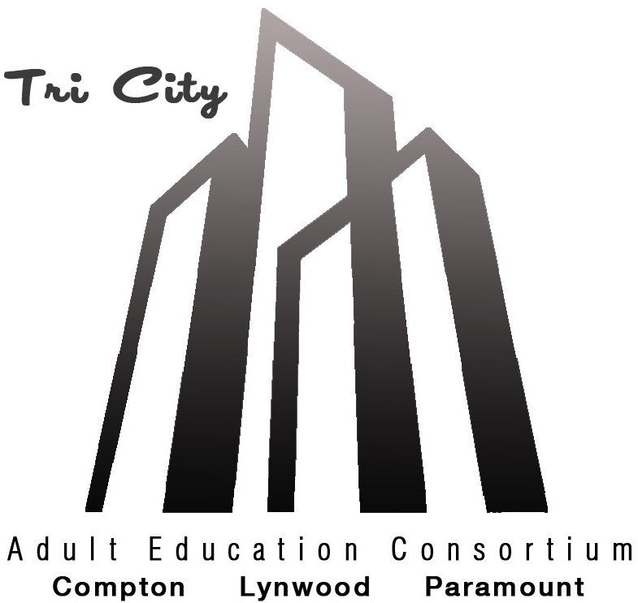
Tri City Adult Education Consortium
Esther Landin
Project Manager
Tri City Adult Education Consortium
elandin@tricityconsortium.org

Executive Board Members:

Lynell Wiggins
Director, Adult Education & Workforce Development
Compton College
lwiggins@compton.edu

Doi Johnson
Principal, Compton Adult School
dojohnson@compton.k12.ca.us

Linda Hembrick
Principal, Lynwood Community Adult School
lhembrick@mylusd.org

Shamell Wilson
Principal, Lynwood Community Adult School
swilson@mylusd.org

Yvonne Rodriguez, Ed.D
Principal, Paramount Adult School
yrodriguez@paramount.k12.ca.us

Submitted:
06/07/19

Table of Contents
Section 1: Consortium Information………………………………………………………………………i
Section 2: Comprehensive Regional Three-Year Plan 1
2.1 Executive Summary 1
2.2 Pre-Planning Assessment…………………………………………………………………………………….3
Table 1. Regional Service Providers………………………………………………………………………………………………….8
Table 2. Funding for Adult Education Programs and Services……………………………………………………………….9
2.3 Community Need and Customers…………………………………………………………………………10
2.4 Identifying Goals and Strategies…………………………………………………………………………..12
Figure 1. Logic Model…………………………………………………………………………………………………………………..13
Table 3. Progress Indicators…………………………………………………………………………………………………………..16
2.5 Piloting and Implementation……………………………………………………………………………….17

Section 2: Comprehensive Regional Three-Year Plan

2.1 Executive Summary
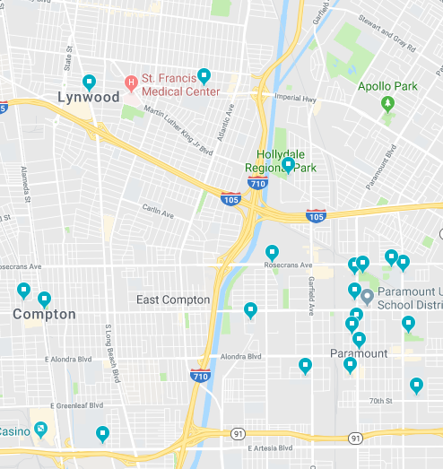
Tri City Adult Education Consortium (Compton College, Compton Adult School, Lynwood Community Adult School, and Paramount Adult School) serves the cities of Compton, Paramount, and Lynwood. It is a unique region, nestled in between Southeast Los Angeles County, Long Beach, and the South Bay. The region is divided by the intersection of the I-710 and I-105 freeways. For those who don't live within the region, it is often used as a corridor to travel to and from the City of Los Angeles, LAX, Orange County, and the beach. As people pass through, they may not realize that the largely Hispanic and African-American populated region has a significantly higher federal poverty-rate than the state average. Because of its geographic location, the region's economy and labor market is viewed within the context of Greater Los Angeles County and Orange County, making it a "hub" for various career pathways opportunities across both counties.
Source: Google Maps
Tri City Adult Education Consortium: Then and Now
The region has experienced steady population growth since 2015, due to a higher number of immigrants largely from Spanish speaking countries residing in the region. Because of this population growth, unemployment has remained stagnant, more adults do not possess a high school diploma, and more adults speak English less than very well; however Tri City Adult Education Consortum serves a similar number of adults as it did in 2015-2016. This demonstrates a continued need for adult education in the region, and Tri City Adult Education Consortium remains vigilant in its mission, "We connect education and workforce training to create family sustaining careers."
The Tri City Adult Education Consortium leadership has also experienced changes. The current Executive Board members were not part of the planning for the 3-year Regional Comprehensive Plan submitted in 2015. However, they have played a critical role in the execution of the plan as well as the direction of the Consortium. The Tri City Adult Education Consortium will continue to transform beginning in 2019-20 under an updated governance structure. Compton College has received full accredidation and will no longer be considered part of El Camino College, therefore will have only one vote instead of two.
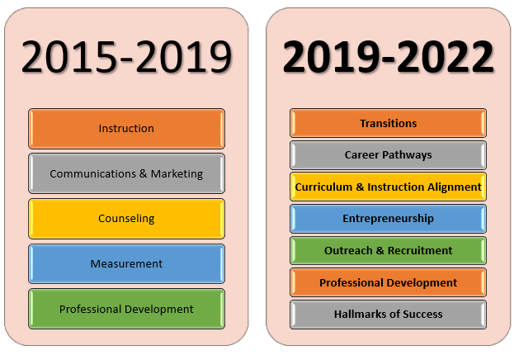
After a self-evaluation process and data analysis, the regional priorities for this 3-year plan are similar to those of the 2015 plan. The regional priorities for the 2019-2022 plan are: Transitions, Career Pathways, Curriculum and Instruction Alignment, Entrepreneurship, Outreach & Recruitment, Professional Development, and Hallmarks of Success.
Chart 1: Comparison of Regional Priorities, Then and Now

2.2 Pre-Planning Assessment
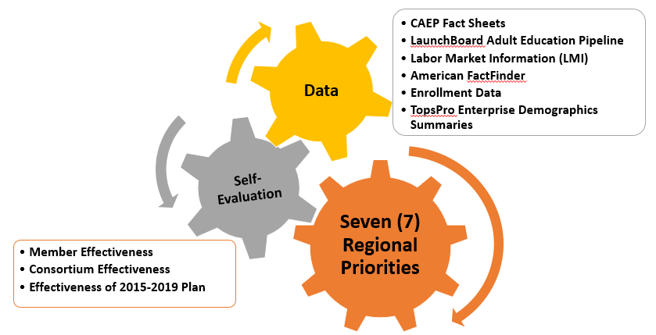
The Tri City Adult Education Consortium Executive Board embarked on a two-tiered strategic planning process. Based on the guidance provided by the California Adult Education Program planning tools, the Executive Board, as well as faculty and staff from each Member, completed a self-evaluation to examine effectiveness as a Member and as a Consortium. The Executive Board also participated in an inventory-exercise that examined the actionable areas of the plan submitted in 2015, and evaluated how well those strategies were executed. Current regional data was then examined and compared to the actionable areas to determine where gaps still exist. A comprehensive list of regional priorities emerged and was narrowed down to seven regional priorities that will fill in the gaps.
Chart 2: Pre-Planning Process
Tier One: Measures of Regional Effectiveness Self-Evaluation
The self-evaluation was designed to evaluate Member and Consortium effectiveness. Although current Executive Board members had not been part of the AB 86 planning process, the results showed that the Members were satisfied with their educational institutions' effectiveness as a Member and the effectiveness of the Consortium throughout the region. However, there is a general consensus that the Consortium needs to develop more capacity to successfully implement strategies for greater student success in the 2019-2022 plan and the subsequent annual plans.
In addition to the self-evaluation, an inventory of the actionable areas listed in the 2015 plan was conducted to evaluate what worked, what did not work and why, and what is still in progress. The actionable areas were ranked by most effective to most ineffective. A couple of notable successes emerged from the inventory. Compton College successfully offers Cosmetology classes at Paramount Adult School, Compton Adult School proudly boasts an 86% placement in employment rate in its Truck Driving program, and Lynwood Community Adult School earned its fifth consecutive 6-year Western Association of Schools and Colleges (WASC) accredidation by the Accrediting Commission for Schools as well as offering a Phlebotomy Technician course three times per year as a new short-term career option. These successful strategies influenced the selection of the seven regional priorities to meet needs of the community.
Tier Two: Data-Informed Planning
Multiple sources of data were examined in order to identify the seven regional priorities. Because the region's geographic location is near the border of two counties, the economy and labor market is influenced by both Los Angeles County and Orange County. This unique situation provides adults in the region with a variety of career opportunities across both counties. Despite the career opportunities that exist, the data revealed a continued need for adult education in the region. The number of adults being served by the Tri City Adult Education Consortium represents a small percentage of the overall adult population of the region. This is an opportunity to reach more adults and provide them with the education, training, experience, and skills to help them transition into the wide variety of career opportunities afforded by the region's unique geographic location.
Examining the data and drawing conclusions was not without challenges. The most recent census data is based on the 2017 American Community Survey 5-Year Population Estimate, and the next census will take place in 2020--one year into the implementation of this plan. Additionally, the most recent data on the LaunchBoard Adult Education Pipeline is from 2017-18, and there is no data available for transitions or employment. There is also a discrepancy between enrollment data provided by AEBG Regional Fact Sheet on Tri City Adult Education Consortium. The AEBG Regional Fact Sheet reflects that 15,674 adult students were served by the region in 2015-16, when local enrollment data reflects approximately 5,500 students served. It appears as if the student population of Compton College was erroneously counted in the students served by the region in 2015-16.
Asset Inventory Mapping
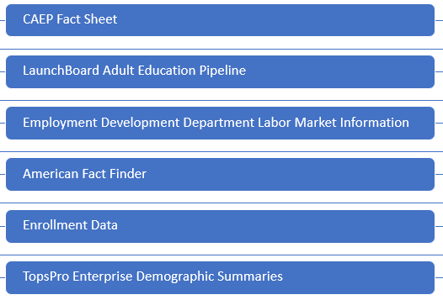
In order to help students overcome barriers to employment and education, they are referred to community based organizations for additional resources throughout the region. Staff from each Member completed the Asset Inventory Mapping to list those community based organizations since they work closely with students and are more aware of the resources students are utilizing in the region. The Asset Inventory Mapping has the potential to be an insightful tool to determine:
Chart 3: Data Sources
- What resources do students need the most?
- What resources do they access the most?
- Are additional resources needed?
Included in the listed regional service providers in Table 1, are:

- Educational Assets
- Health Care Services
- Cultural Assets
- Recreational Assets
- Food System Assets
- Public Safety Assets
- Employment Assets
- Transportation Assets
- Housing Assets
- Organizational Assets

As the wealth of regional services providers were identified through the Asset Inventory Mapping, it became apparent that a referral tracking system is needed to determine what services are being accessed, how often, and whether or not students' needs being met and ultimately leading to greater student success.

Surveys
To better understand where our region stands and determine the direction of this plan, student and staff surveys were created and disseminated among the Members. The surveys were created in Google Forms in order to make it easy to distribute widely. The student survey was also translated into Spanish due to the large number of ESL students served in the region.
The Adult Student Survey contained 15 questions and was answered by 476 students (300 in English, 176 in Spanish) Chart 4.1 and Chart 4.2 below reflect the answers from two questions that illustrate the reasons why our students have enrolled in adult education.
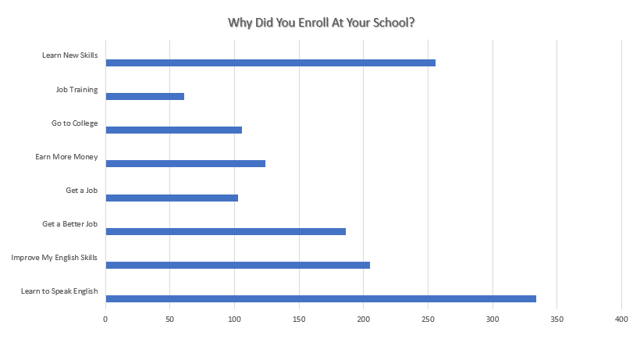
Chart 4.1: Adult Student Survey Results, 479 Respondents
According to the Adult Student Survey, 70% of respondents enrolled in adult education in order to learn how to speak English, and 51% of respondents are employed. The majority of respondents (80%) have internet access at home and primarily access the internet through a smartphone (85%).
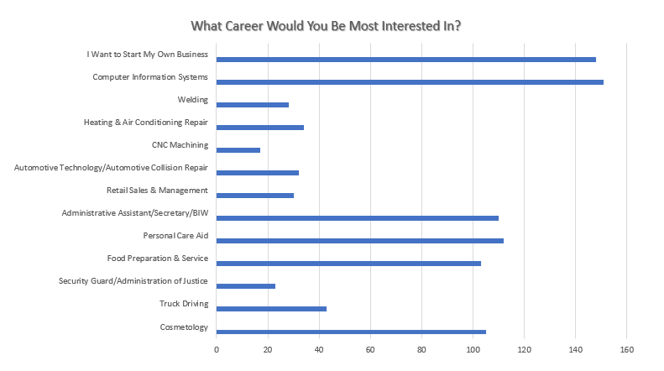
Chart 4.2: Adult Student Survey Results, 479 Respondents
Despite the fact that more than half of students are employed, they are mostly interested in a career in Computer Information Systems (32%) and Entrepreneurship (31%).
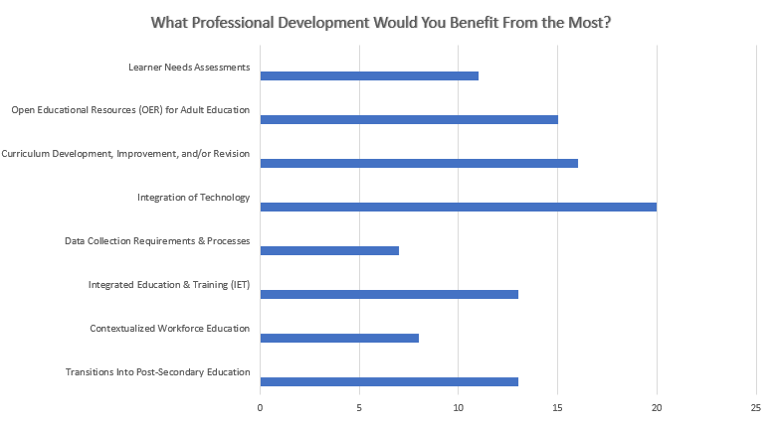
Chart 4.3: Staff Survey Results, 29 Respondents
Twenty-nine (29) staff completed the Staff Survey. 72% of the respondents were adult education faculty/instructors. Although overall, the staff felt the Tri City Adult Education Consortium is effective in helping students succeed, they requested increased communication about the work being done within the Tri City Adult Education Consortium and want to become more involved. Chart 4.3 outlines the need for more Professional Development, in particular in integrating technology.
Leveraging Resources
In addition to its yearly CAEP allocation, the Members of the Tri City Adult Education Consortium receive funding from the Workforce Innovation Opportunity Act (WIOA) Title II Adult Education Family Literacy Act (AEFLA), and the Carl D. Perkins Act (Perkins IV). Compton College also receives Strong Workforce Program funding. However, the allocations are not being included as leveraged resources. Although, like CAEP, Strong Workforce Program is apportionment funding, it is allocated through a competitive application process. Compton College's Strong Workforce Program 2016-17 allocation ended December 2018, the 2017-18 allocation will end in December 2019, and the 2018-19 allocation will end in December 2020. The 2019-20 allocations have not yet been announced as of the date of submission of this plan. Although Compton College's Strong Workforce Program funding is not included as leveraged resources, all other funding streams can be leveraged and braided between all Members toward the seven regional priorities to move the needle toward greater student success. Table 2 outlines the total funding available among the Members of the Consortium.

Table 1. Regional Service Providers
Provider Name | Provider Type | Address or location(s) where AE services are provided | Program Areas |  |  |  |  |  |  |  | If other, provide a brief description of services provided
 |  |  | ABE | ASE | ESL | CTE | AWD | WR | PA | ACS
XYZ Agency | Business / Industry | 555 Adult Education Lane, Los Angeles, CA 90001 | X | X | X | X | X | X | X | X | XYZ agency provides opportunities for students in Manufacturing Bridge Courses to Job Shadow.
Villagren Family Daycare | Child Care | Lynwood |  |  |  |  |  |  |  |  | Daycare Provider
Lynwood Library | Public Library | Lynwood |  |  |  |  |  |  |  |  | Public Library
Jericho Vocational Services Center | Nonprofit | Lynwood |  |  |  |  |  |  |  |  | Employment Services
Wirtz State Preschool | Child Care | Paramount |  |  |  |  |  |  |  |  | Daycare Provider
Paramount Educational Partnership Learning Center | Nonprofit | Paramount |  |  |  |  |  |  |  |  | Hosts ESL classes
Paramount Farmer's Market | Farmer's Market | Paramount |  |  |  |  |  |  |  |  | Held in Progress Park
Lakewood Sheriff Substation | Law Enforcement | Paramount |  |  |  |  |  |  |  |  | Law Enforcement
America's Job Centers of California | WIOA Title I | Various Locations |  |  |  |  |  |  |  |  | Hub Cities Consortium, Rancho Dominguez
MLK Public Library | Public Library | Compton |  |  |  |  |  |  |  |  | Public Library
Martin Luther King, Jr. Community Hospital | Hospital | Los Angeles |  |  |  |  |  |  |  |  | Medical Services
Compton Certified Farmer's Market | Farmer's Market | Compton |  |  |  |  |  |  |  |  | Farmer's Market
Los Angeles County Sheriff | Law Enforcement | Compton |  |  |  |  |  |  |  |  | Law Enforcement
Department of Public Social Services | County Government | Compton |  |  |  |  |  |  |  |  | Public Assistance
The Salvation Army | Nonprofit | Compton
Hopes and Dreams Foundation | Nonprofit | Compton |  |  |  |  |  |  |  |  | Abuse Prevention and Intervention
Douglas F. Dollarhide Community Center | Community Center | Compton |  |  |  |  |  |  |  |  | Parks & Recreation

Table 2. Funding for Adult Education Programs and Services
Source and Type of Funds | Funding Estimates FY2019-20 | Funding Estimates FY2020-21 | Funding Estimates FY2021-22
State / Federal Funding
AEP | $6,278,338 | $6,278,338 | $6,278,338
CalWORKs | $612,649 | $612,649 | $612,649
CCD Apportionment | $25,493,621 | $25,493,621 | $25,493,621
Corrections | $0 | $0 | $0
LCFF / District Funds | $0 | $0 | $0
Perkins V | $53,910 | $53,910 | $53,910
WIOA II | $1,018,802 | $1,018,802 | $1,018,802
Strong Workforce Program | TBD | TBD | TBD
Total | $33,457,320 | $33,457,320 | $33,457,320

2.3 Community Need and Customers
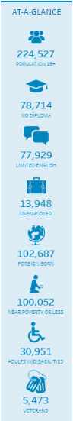
The Tri City Adult Education serves the cities of Compton, Lynwood, and Paramount with an adult population of 224,527. We have two customers to serve: members of the community and employers in the community. Both have unique needs that can be met through adult education.
Chart 5 provides a community profile of the individuals that live within the region. According to the American FactFinder 2017 American Community Survey 5-Year Population Estimate, the average age of an individual living in the region is approximately 30 years old, most likely to be employed, and lives with family rather than independently. When taking a closer look at the community profile and examining the portion of the population that have no high school diploma, have limited English skills, are unemployed, foreign-born, and live at or below the poverty level, we begin to narrow down the target population who can benefit from adult education.
In 2017-18, the Tri City Adult Education Consortium served 5,250 students according to the LaunchBoard Adult Education Pipeline (See Chart 5.2). Of those students, 103 earned a high school diploma. Of the number of students who had 12+ contact hours (3,579), 71% (2,538) were enrolled in English as a Second Language (ESL), and 25% (909) were enrolled in Career and Technical Education (CTE).
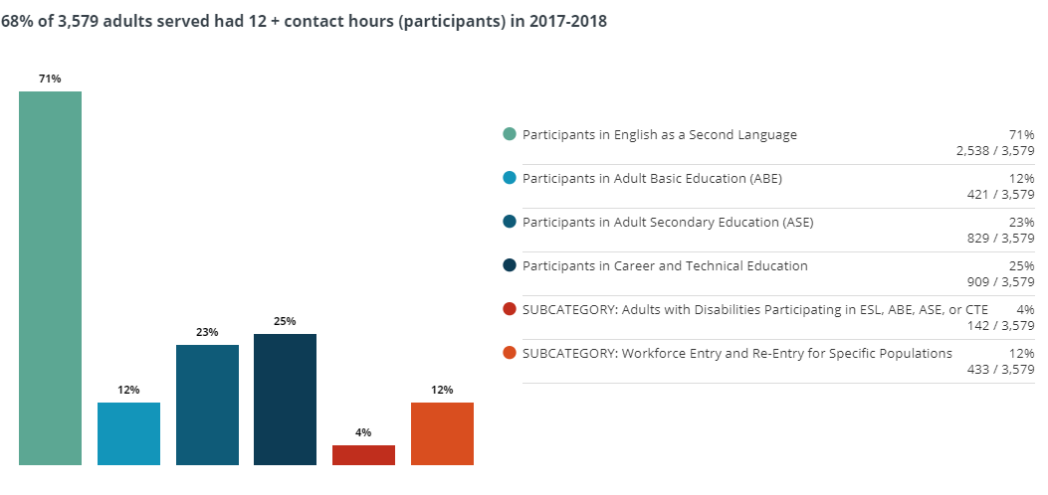
Chart 5.1: Tri City AEC Community Profile
Chart 5.2: Tri City AEC LaunchBoard Adult Education Pipeline Data
Although the student demographics align with the demographics of the community profile, the Tri City Adult Education Consortium serves a small portion of the adult population in the region. There are more adults in the region that need to be served by Tri City Adult Education Consortium. This demonstrates an unmet need in the region as the population continues to grow.
According to the Employment Development Department (EDD) Labor Market Information Help Wanted Online database, the top occupations in the region for the period from January 2019-April 2019 based on the number of job postings are:

- Security Guard
- Heavy and Tractor-Trailer Truck Drivers
- Retail Salespersons
- First-Line Supervisors of Retail Sales Workers
- Registered Nurses
- Combined Food Preparation and Serving Workers

Programs offered by Tri City Adult Education Consortium should align with the labor market demand in order to give students a greater opportunity for career attainment. Paramount Adult School and Lynwood Community Adult School offer nursing programs, while Compton Adult School offers a truck driving program. The Tri City Adult Education consortium will serve as the source for labor market information for each Member to expand, create, or discontinue programs.

2.4 Identifying Goals and Strategies
The Tri City Adult Education Consortium mission statement is: "We connect education and workforce training to create family sustaining careers." However, it is more than a mission statement, it is a goal in itself. It guides the priorities and strategies implemented within the region. The overall goal of this plan is transition. The students served by the Tri City Adult Education Consortium will successfully transition from one program to the next, to college, and to employment through innovative instructional and support service strategies.
The Logic Model in Figure 1 demonstrates how each of the seven regional priorities will be accomplished. It identifies the partners we will collaborate with, the funding that will be leveraged, the outcomes, and what will be measured.
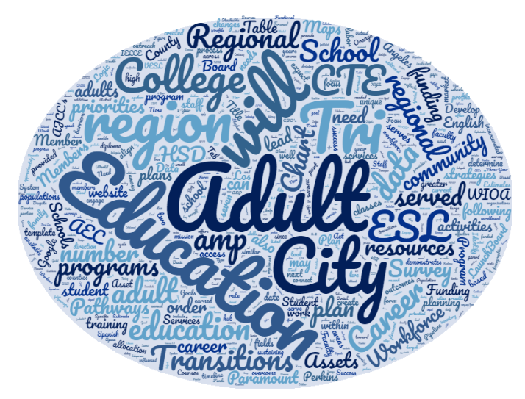

Figure 1. Logic Model
Goal Statement: We connect education and workforce training to create family sustaining careers
Our overall direction and focus for the program cycle relative to the target populations and problems we seek to address
Inputs | Activities | Outputs | Immediate (Short-Term) Outcomes | Intermediate Outcomes | Long-Term Outcomes / Impact
In order to accomplish our set of activities we will need the following: | In order to address our problem or asset we will accomplish the following activities: | We expect that once accomplished, these activities will produce the following evidence or service delivery: | We expect that if accomplished these activities will lead to the following changes in the next year | We expect that if accomplished these activities will lead to the following changes in 1-3 years | We expect that if accomplished these activities will lead to the following changes in 3-5 years
Adult Schools  - WIOA Title II  - Perkins  - ESL Programs  - HSD Programs  - CTE Programs  - Faculty  - Classroom Space  Community College  - Perkins  - CTE Programs  - ESL Programs  - Classroom Space  - Faculty  Workforce Development Boards  - WIOA Title I funded programs  - AJCC Rancho Dominguez  - AJCC Hub Cities  - AJCC Paramount  - Basic Career Services  - Individualized Services  - Supportive Services  - Case Management  - Phase II MOU's  - CalJOBS  Community Based Organizations  Marketing Company/Firm  Subject Matter Expert(s)/Consultant(s) | Adult Schools  - Professional Development  - Collaboration, Co-Location, and Co-enrollments with AJCC's  - Articulation agreements with Compton College  - Career Pathways Maps  - College & Career Success Navigators  - Tutors  - Regional ESL Curriculum & Instruction Alignment-Faculty Workgroup  - VESL Courses  - IET/I-BEST  - Integrated IELCE plans  - Marketing/Outreach  - Workshops on Entrepreneurship  - Referrals to community resources  Community College  - Professional Development  - Collaboration, Co-Location, and Co-enrollments with AJCC's  - Articulation agreements with Adult Schools  - Career Pathways Maps  - College & Career Success Navigators (Counselors?)  - Regional ESL Curriculum & Instruction Alignment-Faculty Workgroup  - VESL Courses  - IET/I-BEST  - Integrated IELCE plans  - New World of Work  - Marketing/Outreach  - Workshops on Entrepreneurship  - Referrals to community resources  Workforce Development Boards  - Collaboration, Co-Location, and Co-enrollments with Adult Schools and Compton College | Implementation of Marketing/Outreach Plan  - Billboards  - Radio  - Bus wraps/benches  - Social Media  - Functional website that serves as a hub  - Outreach to CBO's  - Employer Engagement  Articulation Agreements between Adult Schools and Compton College  Compton College Classes at all three Adult Schools  Stackable Credentials  Adult Schools and Compton College on Eligible Training Partner List  Referral Tracking System on Tri City AEC website  Data sharing between Tri City AEC and AJCC's | Students can enroll in classes via Tri City AEC website  Students can access regional resources to overcome barriers to employment and education via Tri City AEC website | Increase in high school diplomas earned  Increased in certificates/credentials earned  Increased in employment placement rate  Increase in Enrollments in HSD programs  Increase in Enrollments in ESL programs  Increase in Enrollments in CTE programs  Increase in Transitions to Compton College  Increase in Transitions to employment  Increase in Transitions from ABE/ABS to HSD  Increase in Transitions from HSD to CTE  Increase in Transitions from ESL to HSD  Increase in Transitions from ESL to CTE  Increase in referrals to and from the AJCC's  Increase in the number of special populations served: immigrants, individuals with disabilities, formerly incarcerated, Veterans | Decrease in unemployment rate  Increase in Enrollments in HSD programs  Increase in Enrollments in ESL programs  Increase in Enrollments in CTE programs  Increase in Transitions to Compton College  Increase in Transitions to employment  Increase in Transitions from ABE/ABS to HSD  Increase in Transitions from HSD to CTE  Increase in Transitions from ESL to HSD  Increase in Transitions from ESL to CTE  Increase in referrals to and from the AJCC's  Increase in the number of special populations served: immigrants, individuals with disabilities, formerly incarcerated, Veterans

Assumptions | External Factors
Students want to work.  Students want to attend college.  Students are aware of how the educational system works. | Social Supports  Cultural Barriers and Norms

Table 3. Progress Indicators
Provide three to five SMART (Specific, Measurable, Attainable, Realistic, and Time-bound) objectives by which your consortium will assess progress and impact during the next three-year cycle. These objectives should map directly to your Logic Model activities, outputs, and / or outcomes, as these will be a driving factor for annual plans throughout the funding period.
Example: By May 2019, increase the number of agencies that have aligned CTE pathways and developed comprehensive program maps from 2 to 10.
By 2022, students will complete one of three short-term career pathways that lead to employment or transition to Compton College: HVAC, Cosmetology, or Welding
By 2022, at least 25% of students will transition to Compton College.
By 2022, at least 25% of students will transition to employment in a high demand industry through a short-term career pathway.
By 2022, 100% of faculty will attend Professional Development focused on differentiated instruction for English Language Learners and learner persistence.
By 2022, align ESL course outlines to ELPS standards to improve rigor in order for students to successfully access and transition into short-term career pathways.

2.5 Piloting and Implementation
Annual plans will focus on specific strategies that will accomplish the goals and outcomes outlined in this plan, and will include rubrics and benchmarks for evaluation, data collection & reporting. Special populations will also be served in these strategies such as immigrants, adults with disabilities, formerly incarcerated, and Veterans.
Below are potential strategies that will be considered for implementation for each of the regional priorities.
Transitions
- College & Career Navigators
- WIOA Title II Employment & Earnings Follow Up Survey
- National Student Clearinghouse
- Career Readiness Curricula: New World of Work, Get Focused Stay Focused My 10-Year Plan, CASAS Workforce Skills Certification System, Career Cruising/Xello, Nepris
- More Compton College classes at adult schools
- Need to establish baseline data for transition since not available on LaunchBoard or TopsPro Enterprise
Outreach & Recruitment
- Increase enrollments, outreach to CBO's for referrals, outreach to employers for employment opportunities
- A marketing company/firm will be contracted to develop and implement a comprehensive strategy to outreach to residents in the region.
- Functional website to serve as a hub for potential and current students to apply, enroll in classes, and access regional resources
- Social media
- Newsletter
- Geo-targeted Texting
- Outdoor Advertising: bus benches, bus wraps, billboards
- Search Engine Optimization, Google Ads, Google Analytics
- Develop a timeline, benchmarks for achievement, budget
- Develop a message that will ultimately lead to residents in region enrolling in our schools, and employers hiring our graduates.
Curriculum & Instruction Alignment
- ESL curriculum alignment, a Subject Matter Expert will be contracted to lead the effort
- A faculty workgroup consisting of faculty from all four Members will be created and facilitated by the SME. Faculty Stipends. Goal is to align curriculum and COAPPs
- Integrate IELCE plans, WIOA Title II Implementation Survey Results, EL Civics survey results to regionalize COAPPs
- Once alignment is achieved, then focus can shift to IET and VESL in Years 2 and 3
- Develop a timeline, benchmarks for achievement
- Regional course evaluations
Career Pathways
- Pathway Maps that lead from adult school to Compton College to career.
- Pathway Maps that lead from adult school to career.
- Pathway Maps that lead from Compton College to career (Guided Pathways Implementation Plan).
- Articulation agreements
- Stackable credential opportunities
- Referrals to support services to overcome barriers to education and employment
- Regular check-ins/progress reports
- Work-based learning
- College & Career Navigators
- Develop a timeline, benchmarks for achievement
Entrepreneurship
- Partner with agency who has expertise
Professional Development
- High quality, evidence-based Professional learning & development
- Develop Professional Learning Communities and/or Communities of Practice around ESL, CTE
- Adult Education Leadership Institute-CalPRO (Administrators, Directors, Lead Faculty)
- CASAS Proctor training & e-testing
- CASAS Summer Institute
- Outeach and Technical Assistance Network (OTAN)
- CAEP Summit
- Career Pathways Leadership Institute
- Institutional Effectiveness Partnership Initiative (IEPI)
- TAP Webinars
- Coalition on Adult Basic Education (COABE)
- CA Council of Adult Education (CCAE)
- Association of CA School Adminstrators (ACSA)
- Association of Community and Continuing Education (ACCE)
- CA Adult Ed Administrators Association
- CA Teachers of English to Speakers of Other Languages (CATESOL)
- Technology Information Center for Administrative Leadership (TICAL)
- LINCS
Hallmarks of Success
- LaunchBoard
- NOVA
- CTE OS
- CalJOBS
- MIS
- TopsPRO Enterprise
- Local data collection and data source verification

